WARRANT VALIDATION PROCEDURES LEGACY AND BEST
Originator: | Jason Malveaux |  | Effective Date: | February 19, 2013
Manager Approval: | Rolando Mendoza |  | Original Date: | January 30, 2013
Revised by: | Sender De La Roca |  | Revision Date: | May 10, 2019
Purpose
This procedure outlines what needs to be done and what to look for when validating A-Warrants and B-Warrants for BEST or Legacy systems.
Procedure

Step 1 – Ensure MICR Validation

Data Control accepts the warrants from the printer operator and proceeds with the MICR reader validation. During the MICR reading process the Data Control clerk inspects the print quality of the warrants.

Step 2 – Separation by Business Unit and Warrant Validation
Data Control will separate the warrants into their business units (Districts).
The Districts are to be stacked one on top of the other in a crisscross pattern.
The following should be present in all warrants
- Warrants should be clean – free of smudges, smears, blotches of toner fused during printing.
- No verbage should be obscured, especially on the actual check portion.
  - Note: some dotting or minor blotching may be passable, but in this case the Data Control Clerk must have the Senior Data Control Clerk or Operations Shift Supervisor inspect the warrant before accepting it as valid.
- All print, other than the control number, should remain within the confines of the warrant. No print should appear outside of the green (A-Warrants) or pink (B-Warrants) boundaries of the warrants.
  - Note: Fan the warrants. The print gives the appearance of a flip book. If the MICR numbers appear to jump up and down this means that the image of the warrant is riding too high or low. If the image is too high, then verbiage may be cut off at the top of the check. If it’s too low, then the MICR number may not read at the banks and invalidate the warrant.
- The proper signatures should appear on all warrants above the line given for their position.
- The “Pay to the Order of” entry and the amount must appear within their given boundaries
- The government Logo must appear on all warrants in its prescribed position.
  - This example is using an A-Warrant for HRS Legacy
  - Use same criteria not layout for BEST FIN, HCM and PeopleSoft B-Warrants
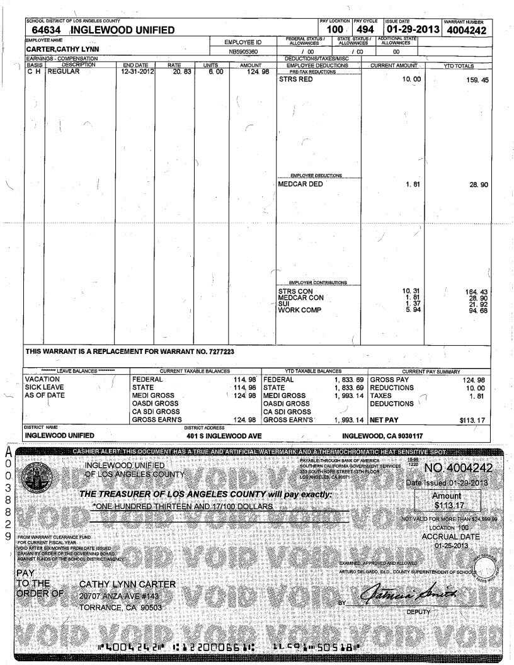
Security tab changes color as heat is applied from pink to white
Note the missing toner
This warrant failed the MICR test and is invalid…Request a Reprint of the warrant
IMPORTANT: The first and last warrant of each crisscrossed business unit must have the same district number. Be careful as districts have similar names and district numbers.

Step 3 – Double Check

A second Data Control Clerk, a fresh pair of eyes, should inspect the Warrants to ensure that the warrants for each business unit are complete and no two districts appear as one business unit.

Step 4 - Distribute

For Legacy, HRS and PeopleSoft:
The validated warrants are put on the large gray metal carts separately marked for A and B warrants. Place all valid, double-checked and crisscrossed warrants on their respective carts.

For BEST, FIN and HCM,
The validated warrants are put on the special carts marked “BEST WARRANTS ONLY”
Place all valid, double-checked and crisscrossed warrants on these carts only.

Operations will deliver these carts with warrants every day to Support Services in room EC-180.
Authorized personnel only will have access to this room using their badge. Entry to this room will record the time we delivered the warrants to SFS for distribution.

